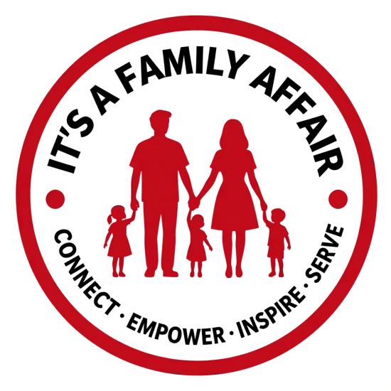
IT’S A FAMILY AFFAIR
2027 SCHOLARSHIP APPLICATION REQUIREMENTS & ESSAY INSTRUCTIONS
Connect • Empower • Inspire • Serve
Application Period: February 1, 2027 – April 12, 2027 | Recipient Notification: May 2027

Scholarships Available
- Louis Academic Award — one $500 award
- Vivian Impact Scholarship — one $500 award
- Ray’s Resilience Scholarship — one $500 award
Required for Every Application
- Completed online scholarship application submitted by the deadline.
- Original 300–500 word essay responding to the prompt for the scholarship selected.
- One recommendation letter from a teacher, counselor, supervisor, mentor, community leader, or another person able to describe the applicant’s qualifications or character.
- Academic transcript. The transcript will be used to verify academic information, including GPA.
- Applicant certification, electronic signature, and date signed.
Essay Instructions
Choose the essay prompt for the scholarship you are applying for. Your essay must be 300–500 words and should directly answer the selected prompt. Upload the completed essay with your online application.
Louis Academic Award
Describe your academic journey, educational goals, and how this scholarship would help you continue your education.

Vivian Impact Scholarship
Describe a time you made a positive difference in someone’s life, your school, or your community. What motivated you, what impact did you make, and what did you learn?

Ray’s Resilience Scholarship
Describe a significant challenge you have overcome or are working to overcome. How have you demonstrated perseverance, what have you learned, and how has the experience influenced your educational goals?

How Applications Are Reviewed
Applications are reviewed using the approved eligibility and selection criteria for the scholarship selected. Reviewers consider the information and documents submitted with the application. Submission of an application does not guarantee a scholarship award.
- Louis Academic Award: academic achievement, commitment to education and educational goals, essay/personal statement, and other approved criteria.
- Vivian Impact Scholarship: positive impact, service/leadership, character and commitment, essay/personal statement, and other approved criteria.
- Ray’s Resilience Scholarship: perseverance and growth, commitment to future educational goals, essay/personal reflection, character/service/leadership, and other approved criteria.
Important Application Reminders
- Applications open February 1, 2027 and must be submitted by April 12, 2027.
- Incomplete applications or applications missing required documentation may not be considered.
- Applicants should upload clear, readable documents.
- Recipient notification will take place in May 2027.
www.itsafamilyaffair.org

